EdPsych 490 CK / Psych 493 CA
Fall 2001
C.J.Anderson

Using SAS/ASSIST
To Produce Graphs

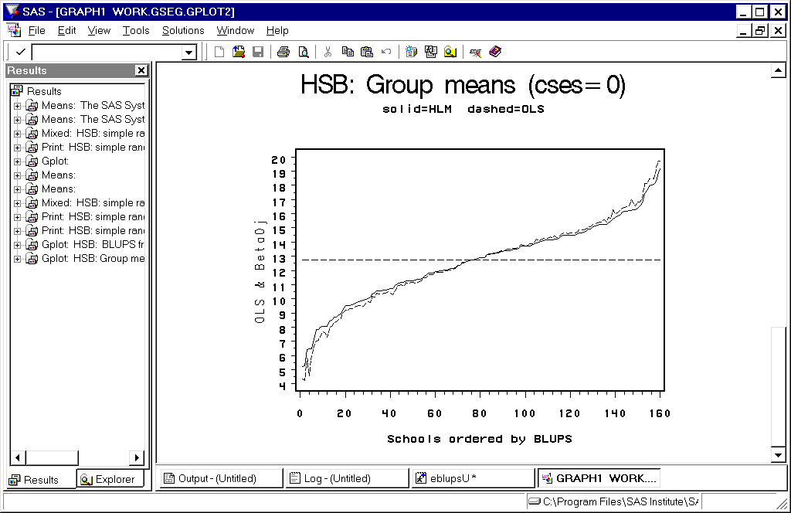

Under “Solutions” on the SAS toolbar select “ASSIST”

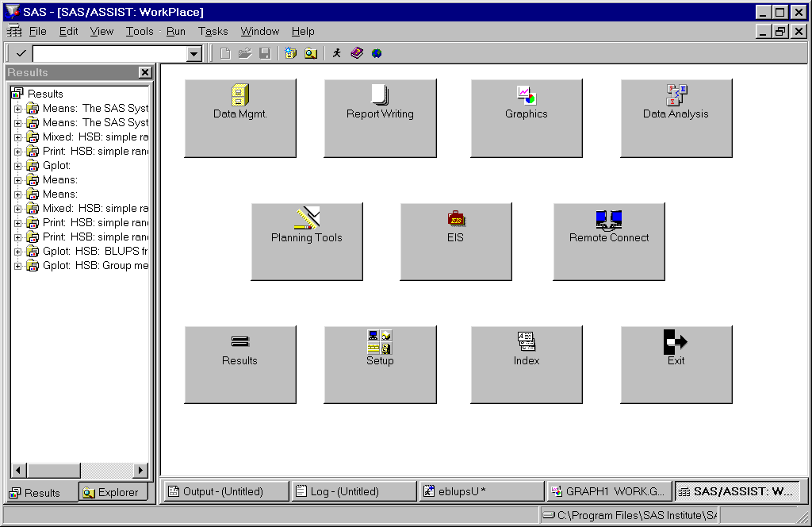

Select “Graphics”.
You will be able to select from
- Bar Charts…
- Pie Charts…
- Plots…
- Maps…
- Utilities

Select “Plots”, which will then allow you to select from
- Simple X*Y Plot…
- X*Y Plot…
- Multiple Plots per Axes…

Select “Multiple Plots per Axes”. The following window will open.

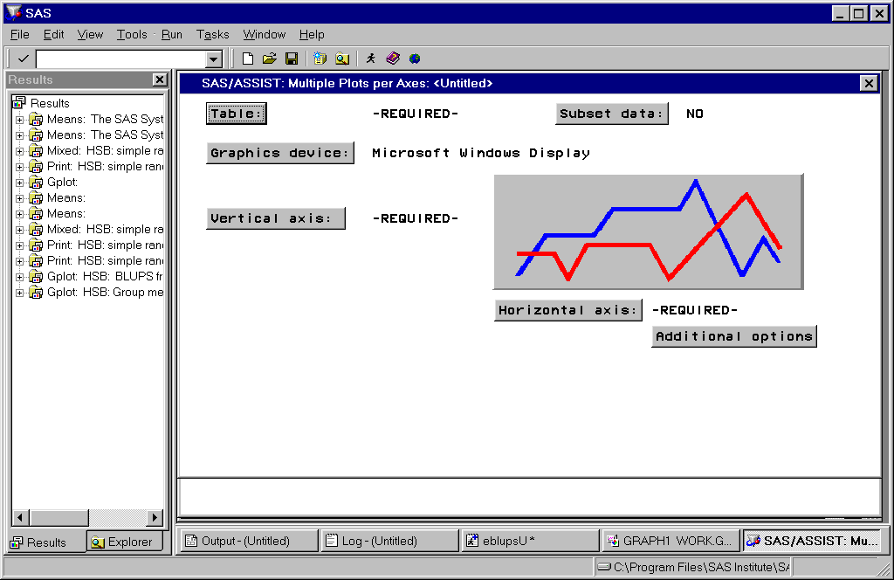

To graph the predictions of U_j along with the confidence bands click on the “Vertical axis” button:

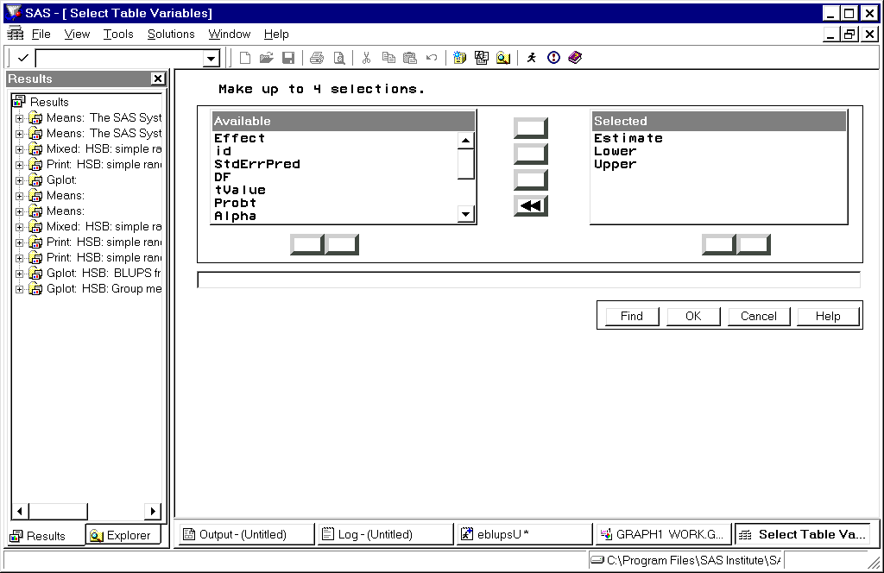

You put as many variables in the “Available” list into the “Selected” box as you want plotted. Then click on “OK”.

Do the same with the “Horizontal axis” (can only select one variable).

Click on “Additional Options” (you will generally want to make changes to the default settings).

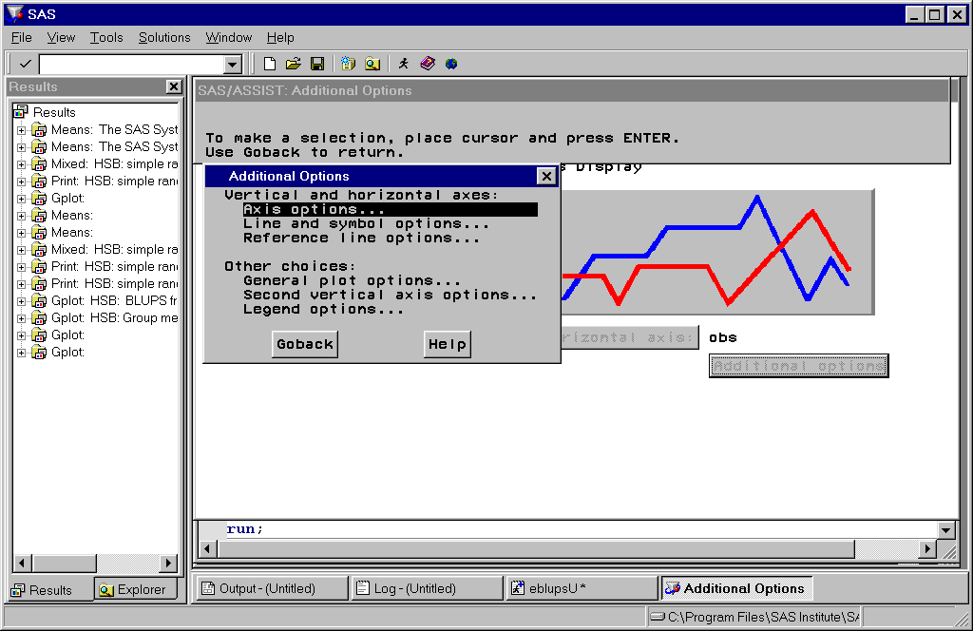

If you selection “Axis options” you then select “Vertical” or “Horizontal”. You can then adjust the following

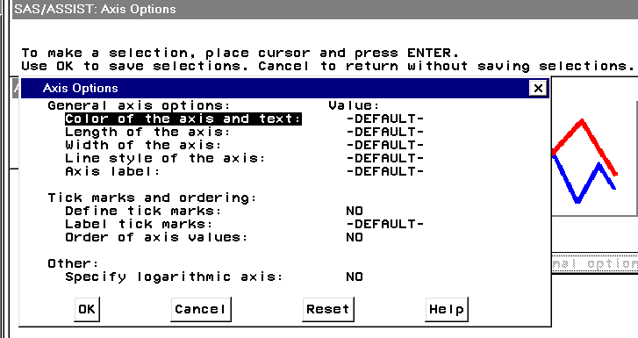

For example, select “Axis label” to enter a more meaningful label for the vertical axis…

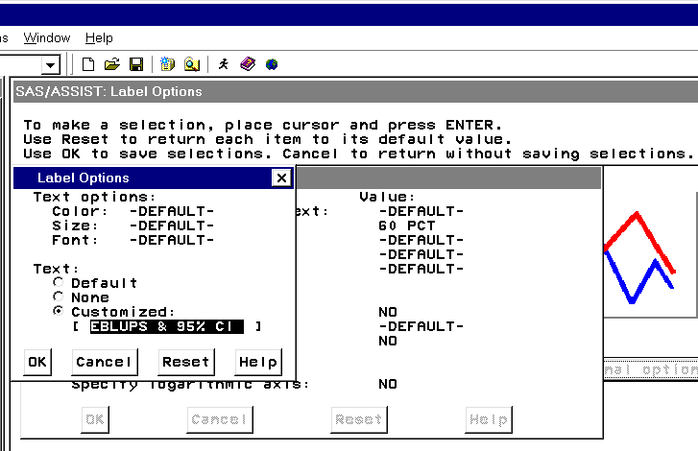

With multiple plots per axis you will want to modify “Line and symbol options”:

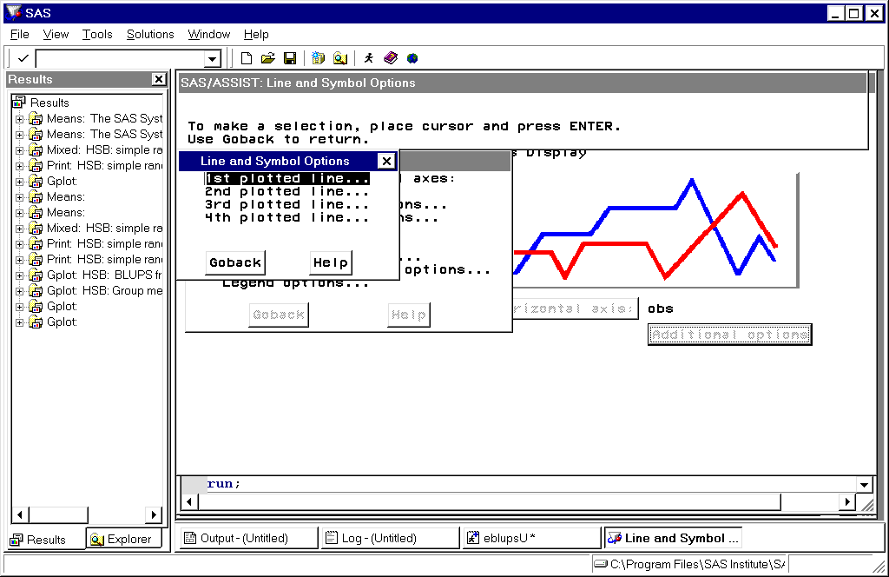

The “1st plotted line…” will be the line for the first variable listed under “vertical axis” in the main graph window.

Selecting “1st Plotted line…” opens the following

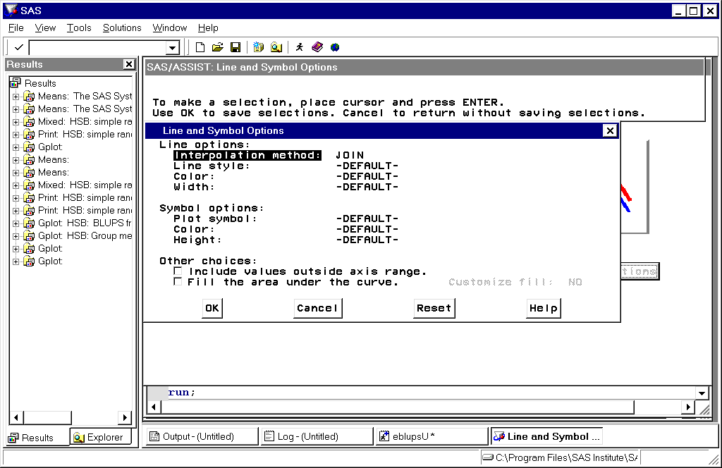

The default interpolation method is to “JOIN” points by a straight line. We’ll do this for the predicted values of U_j.

The default symbol is “None”.

Now lets do this for the 2nd plotted line, which will be the lower 95% CI:

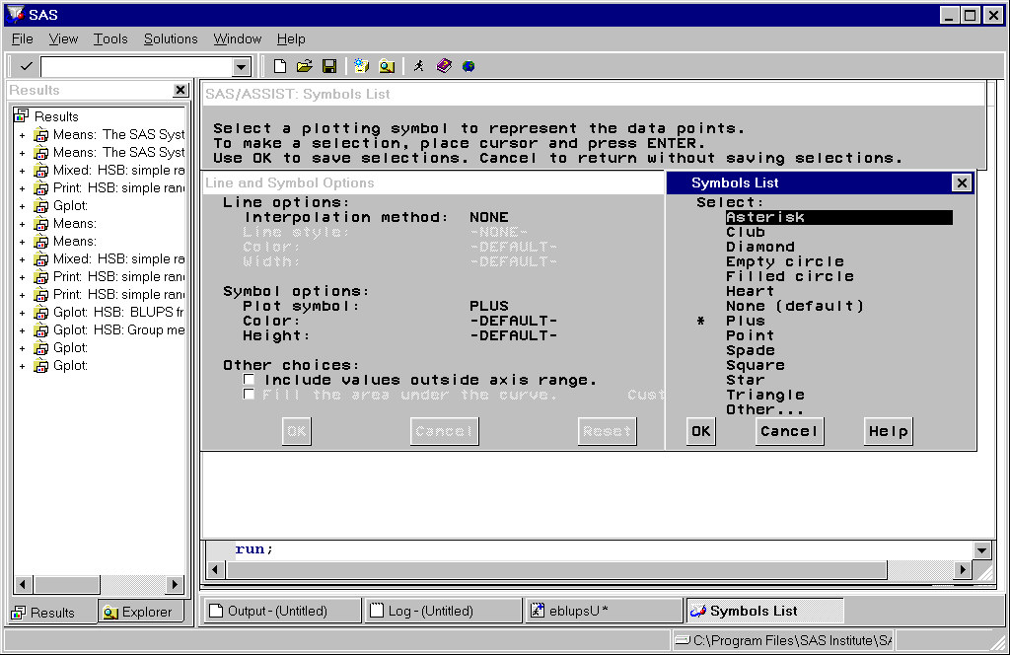

I decided to use “+” to indicate the lower CI.

Also, I didn’t want them connected by a line so under “Interpolation Method” I select “Leave points unconnected”, which is the first option. Below are the options for “Interpolation Method”

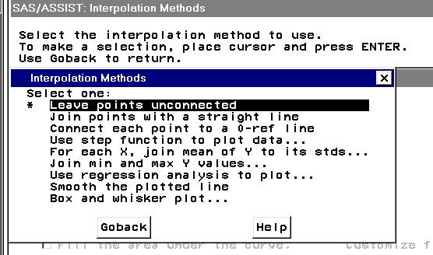

After making all “Additional Options” that you want, click on the run icon (or submit).
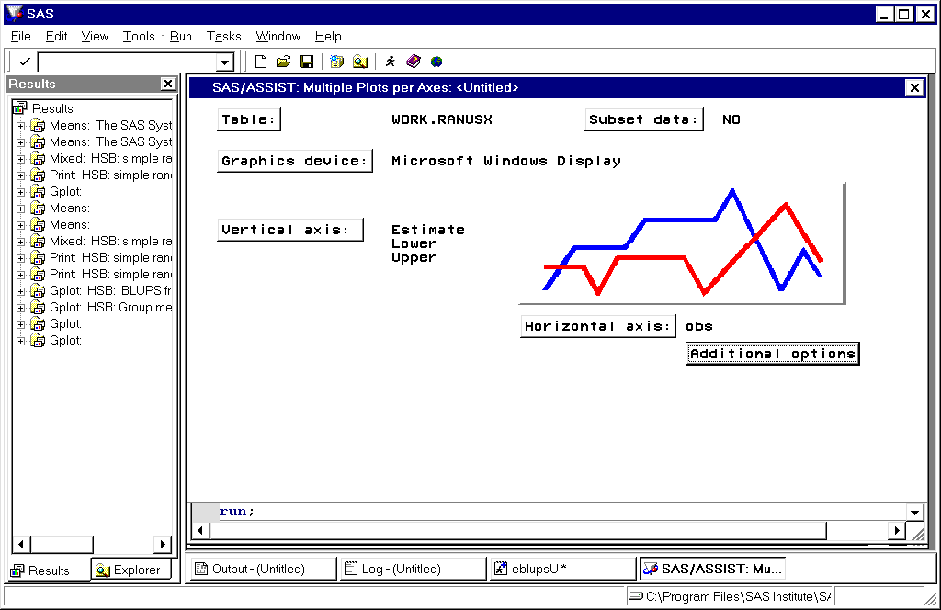

And you get….

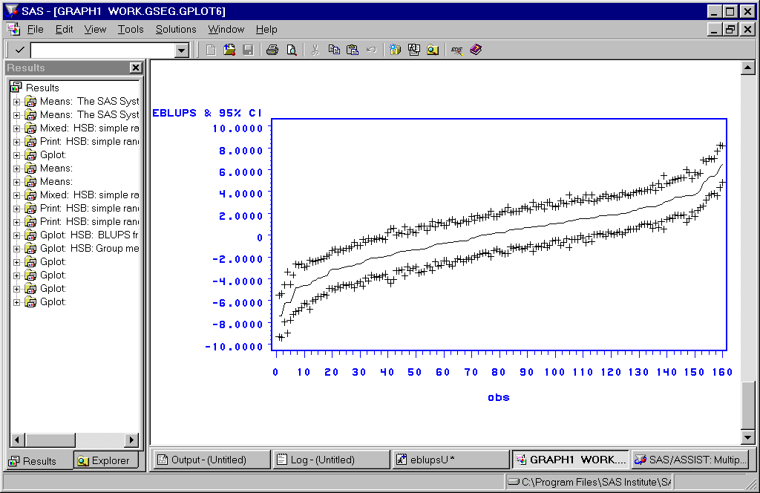

To save this figure, under “File” on the main toolbar go to “Export as Image”.

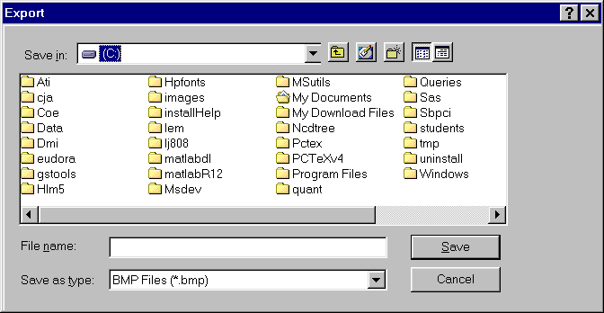

You will need to fill in the following:
- Where you want the file to live.
- The name you want to give the file.
- The format of the file (“Save as type:”). Possible formats are:

  - BMP file (*.bmp)
  - EMF file (*.emf)
  - WMF file (*.wmf)
  - JPEG file (*.jpg)
  - GIF file (*.gif)
  - TIF file (*.tif)
  - PS file (*.ps)
  - EPSI file (*.ps)
  - PBM file (*.pbm)
  - DIB file (*.dib)

Lastly, the SAS/GRAPH code is given to you in the SAS/LOG. I often copy this into the program editor and make changes, such as adding titles and editing graphs…editing can also be done with graphs when you’re using SAS/ASSIST.

